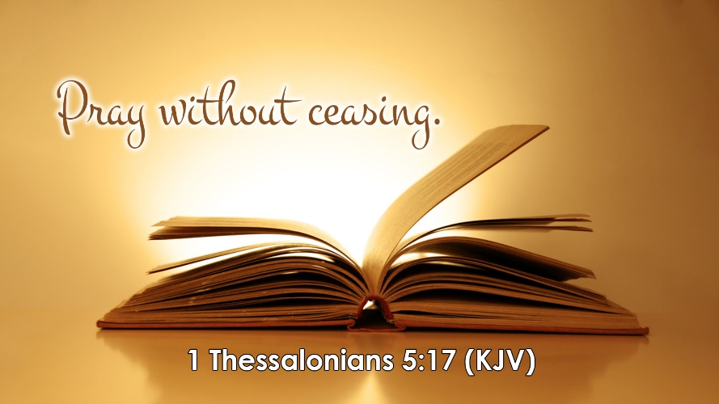

A Prayer of Healing

Father, in the Name of Jesus, I need to touch the hem of your garment so that I will be made whole. Forgive me for my sins. I am asking You for the healing of my body, mind, and spirit. Let your healing power flow through my body so that my health is restored like a well-watered ever-flowing spring. I am persevering through for your healing touch to be manifested in my body. I curse the root of sickness and disease in my body, and I command it to go, in the Name of Jesus. I speak to every organ, every gland, and every system in my body and command all of them to operate and function at 100% efficiency. I speak life and health to every area of my body, and I proclaim that I am healed, cured, healthy and whole, and I thank You for my healing in Jesus Mighty Name of Jesus, amen.

